Blue-White FLEXFLO M3 Peristaltic Metering Pump
- METERING PUMP – Shall be a positive displacement, peristaltic type tubing pump with a brushless variable speed motor, non-spring-loaded roller assembly located in the pumphead, integral tube failure detection system, tube life roller revolution counter with user alarm set-point and flexible tubing with attached connection fittings. FLEXFLO M3 model shall be capable of output volumes from 0.0002 to 33.3 gallons per hour (0.0007 to 126 liter per hour).
  - There shall be no valves, diaphragms, springs, or dynamic seals in the fluid path. Process fluid shall contact the pump tubing assembly and connection fittings only.
  - Pump shall be capable of 24-hour continuous duty, self-priming and operating in either direction of flow at the rated maximum pressure of up to 125 PSI (8.6 bar).
  - Pump shall be capable of running dry without damage.
  - Pump shall be capable of operating in either direction without output variation.
  - Suction lift shall be 30 feet (9.14 m) of water.
  - Pump shall be warranted by the manufacturer for a period of five years. Warranty shall include chemical damage to the pump head and roller assembly for a period of two years.

- PUMPHEAD – Shall be a single, unbroken track with a clear removable cover
  - Tube failure detection sensors shall be constructed of two Hastelloy C pins that are located at the bottom of the pump head. The Hastelloy C pins shall act as electrical contacts. When both Hastelloy C pins are immersed in a conductive fluid, a circuit shall be completed between the pins and indicate a tube failure has occurred. Tube failure detection system shall not trigger with water contact from rain or condensation. Float type switches shall not be used. Process fluid waste ports or leak drains shall not be provided.
  - Squeeze rollers with encapsulated ball bearings shall be directly coupled to a one-piece thermoplastic rotor. Four nylon rollers shall be provided; two squeeze rollers for tubing compression shall be located 180 degrees apart and two guide rollers that do not compress the tubing shall be located 180 degrees apart. The roller diameters and occlusion gap shall be factory set to provide the optimum tubing compression; field adjustment shall not be required. Spring-loaded or hinged rollers shall not be used.
  - Rotor assembly shall be installed on a D-shaped, chrome plated motor shaft and removable without tools.
  - For tubing installation and removal, rotor assembly shall be rotated by the motor drive at 6 RPM maximum when the pumphead cover is removed. Hand cranking of the rotor assembly shall not be required.
  - Pump head and tubing compression surface shall be corrosion resistant Valox thermoplastic.
  - The pump head cover shall be clear, polycarbonate thermoplastic with an integral ball bearing fitted to support the overhung load on the motor shaft. Cover shall include an imbedded magnetic safety interlock which will limit the motor rotation speed to 6 RPM when removed.
  - Cover shall be positively secured to the pump head using a minimum of four thumb screws. Tools shall not be required to remove the pump head cover.

- PUMP TUBE ASSEMBLY
  - To ensure pump performance and accuracy, only tubing provided by the manufacturer is acceptable.
  - Pump tube shall be assembled to connection fittings of PVDF material.
  - Connection fittings shall be permanently clamped to the tubing with stainless steel clamps or over molded directly to the tubing. To prevent tubing misalignment and ensure accuracy, fittings shall insert into keyed slots located in the pump head and secured in place by the pump head cover.
  - Connection fittings shall be 1/2” M/NPT. (Engineer to specify)
Alternate:
- Fittings shall accept 1/4” ID x 3/8” OD flexible tubing.
- Fittings shall accept 1/2” ID flexible tubing.
- Fittings shall accept one-way check valve Quick Disconnect Adapters. Wetted components shall be PVDF, Viton (optional EPDM), and Hastelloy C spring.
- Fittings shall accept ¾” tri-clamp adapters.
  - Tube sizes and connections shall be measured in inches.
  - The following tube sizes shall be available:

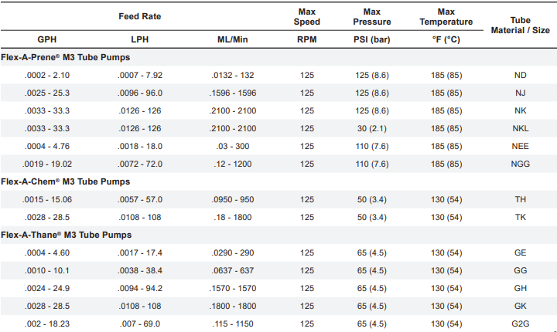

- DRIVE SYSTEM – Shall be factory installed and totally enclosed in a NEMA 4X, (IP66) wash-down enclosure. Capable of operating on any input power from 110VAC to 240VAC, 50/60 Hz single phase supply without user configuration or selection switches.
  - Motor
    - Reversible, brushless DC gear motor rated for continuous duty.
    - Motor shall include overload protection.
    - The maximum gear motor RPM shall be 125 RPM.

  - Enclosure
    - Bottom housing shall be pressure cast aluminum with acidic liquid iron phosphate three-stage clean and coat pretreatment and exterior grade corrosion resistant polyester polyurethane powder coat.
    - Top housing shall be structural foam molded Noryl engineered thermoplastic.
    - Rated NEMA 4X (IP66).
    - Provided with 316SS floor/shelf level mounting brackets and hardware. Optional: provide extended height brackets for mounting pump 4.5 inches above grade level. (Engineer to specify)
    - M12 receptacles shall be located at the rear of the pump for input and output signals.
    - RJ45 receptacle shall be located at the rear of the pump for use with EtherNet/IP and Modbus TCP/IP
    - One M12 receptacle shall be located at the rear of the pump for use with Profibus

  - Control Circuitry. All control circuitries shall be integral to the pump.
    - All control circuitries shall be integral to the pump and capable of adjusting the pump motor speed from 0.01% to 100.0% in 0.01% increments less than 10% motor speed, in 0.01% and in 0.1% increments greater than 10% motor speed (10,000:1 turndown ratio).
    - The pump output shall be capable of being manually controlled via front panel touchscreen. The pump motor speed shall be adjustable from 0.01% to 100.0% in 0.01% increments less than 10% motor speed and in 0.1% increments greater than 10% motor speed.
    - The pump output shall be capable of being remotely controlled via 4-20mA analog input. The input resolution shall be 0.01 of input value and capable of adjusting the pump motor speed from 0% to 100.0% motor speed in 0.1% increments. Four values shall be user configurable to define the low and high points on the output slope: a low input value, the required pump percentage of motor speed at the low input value, a high input value, the required pump percentage of motor speed at the high input value.
    - The pump output shall be capable of being remotely controlled via TTL/CMOS digital high-speed pulse type input and an AC sine wave type pulse input in the range of 0 to 1,000 Hz. The frequency resolution shall be 1 Hz and capable of adjusting the pump motor speed from 0% to 100.0% motor speed in 0.1% increments. Four values shall be user configurable to define the low and high points on the output slope: a low input value, the required pump percentage of motor speed at the low input value, a high input value, the required pump percentage of motor speed at the high input value.
    - The pump output shall be capable of being remotely controlled via pulse triggered batching. The pump shall accept a TTL/CMOS digital pulse type input and a contact closure type pulse input in the range of 1 to 5,629,499,534,21,312 pulses per batch. The batch time shall be adjustable from 1 to 5,629,499,534,21,312 seconds. The pump motor speed during the batch shall be adjustable from 0% to 100.0% motor speed in 0.1% increments.
    - Pump shall be capable of remote priming via non-powered contact closure loop
    - The pump output shall be capable of being controlled via EtherNet/IP, Modbus TCP/IP, or Profibus. Device configuration shall be as follows:

Control and Status Mapping for Profibus and EtherNet/IP:

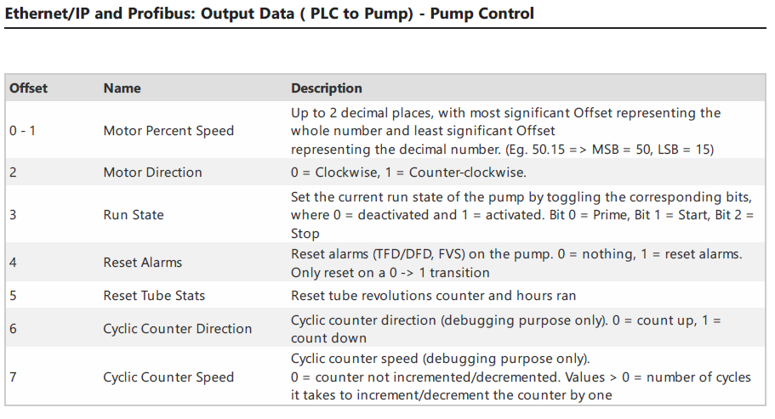

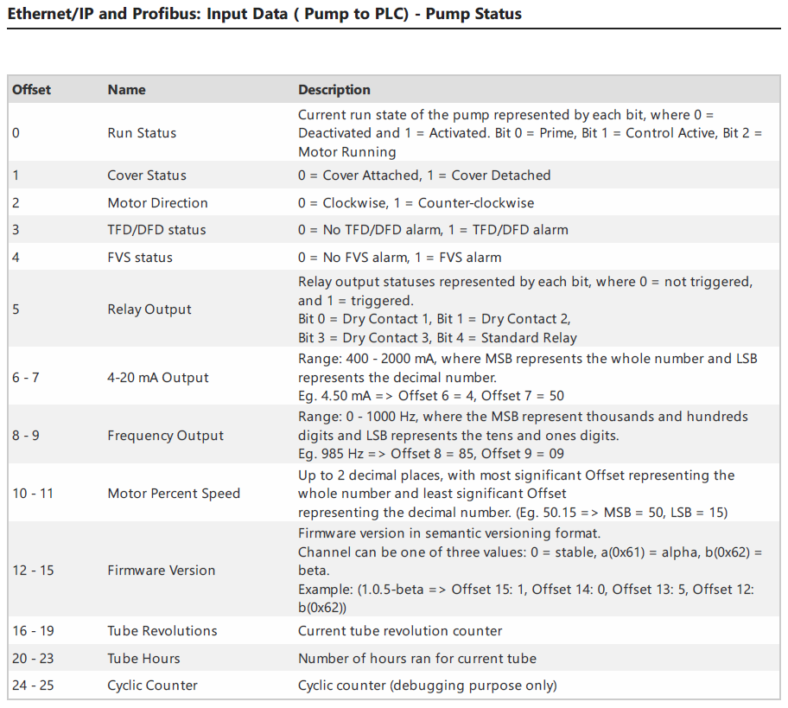

Control and Status Mapping for Modbus TCP/IP

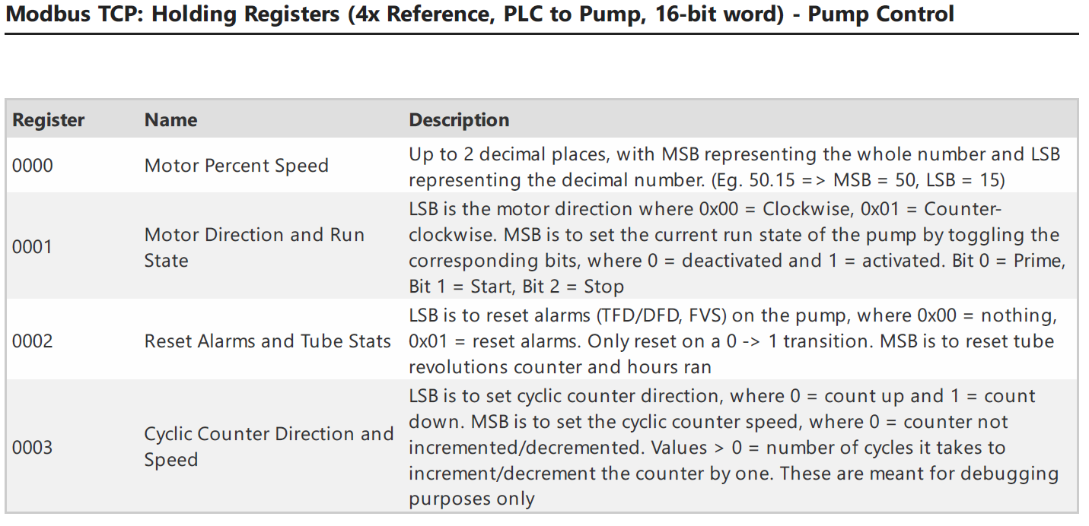

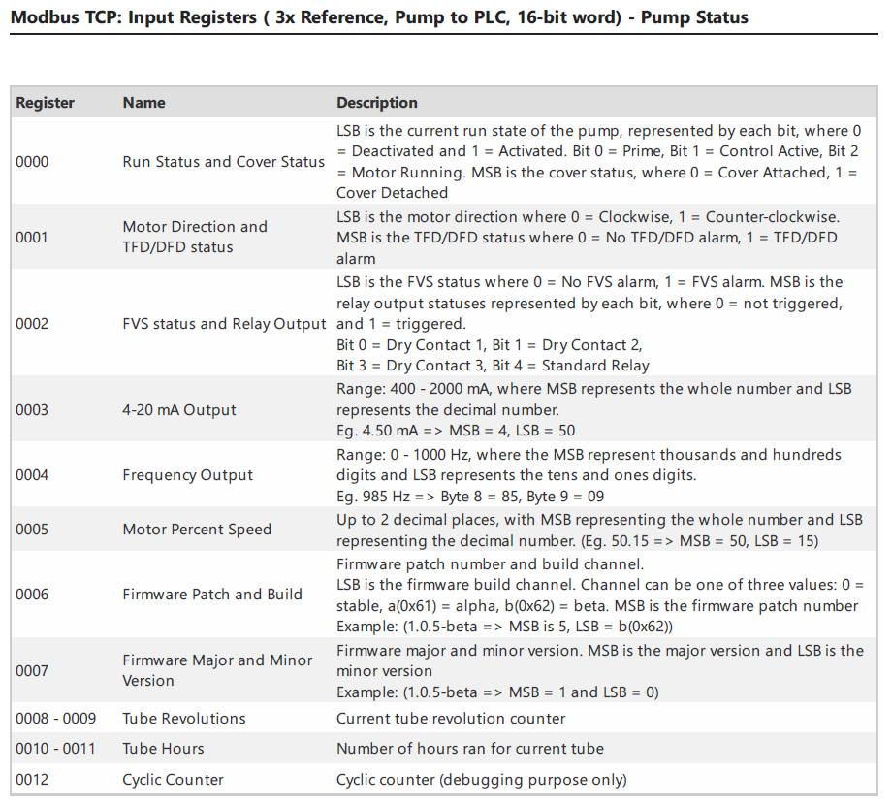

    - Provide a front panel touchscreen control for stop/start, configuration menu access and navigation, operating mode selection, display options selection, tube info data, and reverse direction.
    - Provide a multi-color LCD touchscreen display for menu driven configuration settings, pump output value, service alerts, tube failure detection (TFD) system and flow verification system (FVS) alarms status, remote input signal values, tubing life timer value. Display color shall be green when indicating run operation, blue when in idle, yellow when in stand-by, and red to indicate an alarm condition exists.
    - Provide for remote stop/start pump via non-powered contact closure loop.
    - Provide a user selectable 4-20mA and 0-1,000Hz output signal which are scalable and proportional to pump output volume.
    - Provide four contact closure alarm outputs. Three rated at 1A-115VAC, 0.8A-30VDC and one rated at 6A-250VAC, 5A-30VDC. Each alarm output shall be assignable to monitor any of the following pump functions: TFD system, FVS system, motor run/stop, motor failed to respond to commands, motor is running in reverse, general alarm (TFD, FVS, and/or motor over current), input signal failure, output signal failure, remote/local control status, revolution counter (tube life) set-point, or monitor which of the nine different pump operating modes is currently active.
    - Provide a six-digit password protected configuration menu.
    - Provide a flow verification system with programmable alarm delay time from 1-1000 seconds. FVS system shall monitor the FVS flow sensor while pump is running only. System shall not monitor pump while not running.

- FLOW VERIFICATION SENSOR – Shall output high-speed digital pulse signal or 4-20 mA, while pump is running only, to verify chemical injection.

  - Flow verification sensor shall be an ultrasonic transit time sensor.
  - Wetted components shall be PVDF (optional PVC), PEEK, and TFE/P (optional EP).
  - End fittings shall be PVDF with optional PVC slip fittings. All are included.
  - Sensor operating range shall be as follows: (Engineer to specify)
Code Flow Range (GPH) Flow Range (LPH) Flow Range (mL/min)
A 0.158-79.2 0.597-299.4 10.0-5,000
B 1.580-158.5 5.970-600.0 100-10,000
  - Shall provide a scalable 4-20 mA sourcing output.
  - Shall provide a scalable 0-1,000 Hz open collector frequency output
  - Shall provide a programmable Form C Solid State Relay rated for a maximum load capacity of 24 VDC and 100 mA.
    - Programmable for high/low flow rate alarm.
    - Programmable to energize on specified flow total.
  - Power Requirements: 5 VDC; 5 Watts maximum.
  - Shall be certified to NSF Standard 61 Drinking Water System Components.
  - Accuracy shall be +/- 0.75% full scale. Accuracy shall be +/- 0.25% at the field calibrated setpoint.
- SAFETY
  - The pump shall be certified to NSF Standard 61 Drinking Water System Components, UL standard 778 motor operated pump and CSA standard C22.2 process control equipment.
  - Manufactured to ISO 9001:2015 requirements and processes.
  - Tube Failure Detection (TFD) system sensors shall be wholly located in the pump head. TFD system will stop the pump within three seconds of leak detection. To prevent false alarms due to rain, wash-down, condensation, etc., tube failure detection system shall not trigger with water contact. Process fluid waste ports or leak drains shall not be provided.
  - Pump head cover shall include an imbedded magnetic safety interlock which will stop the pump when removed. Pump rotor speed shall be limited to 6 RPM when cover is removed.
  - Secondary user confirmation input required for motor reversal, tube life revolution count reset, and factory default configuration reset.

- Manufacturer
  - The pump shall be FLEXFLO Municipal peristaltic pump, manufactured in the U.S.A. by Blue-White.

